Welcome Meeting |  |  |  | 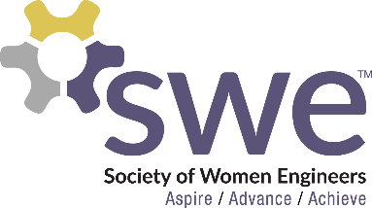  9.03.2019
 | AGENDA  Updates  - Meet the 2020-2021 Officers!  Outreach  - Tech Kids: Every Monday 9/9-11/4, 5-6:30 PM  - Mommy, Me & SWE: Saturday, September 28, 9-12 AM  - Please be at the CoE Admin Building at 8 AM  - Tech Teens: Saturday, October 26th, 9-12 AM  - Please be at the CoE Admin Building at 8 AM  Fundraising  Corporate Relations  - Resume Building Event: September 23rd 5:30-7:30 p.m. A. Glenn Hill 122 (Monday before the Career and Tech Expo)  - CNH Tour September 26th 1:00-5:00 p.m  Membership  - Picnic @ Churchill Field, 9/18, 7-9 PM  - Located in front of the A.G. Hill STEM Building!  - Mentor/Mentee Program  Photos  - We would love you to send your SWE photos to ndsuswe@gmail.com!  Get to Know Each Other!  - Slido Game |  |  |  | OFFICERS  President:  Kjersten Winkelman  kjersten.winkelman@ndsu.edu  VP of Membership (Fall):  Sabrina Kase  sabrina.kase@ndsu.edu  VP of Outreach:  Breeya Pederson  breeya.pederson@ndsu.edu  VP of Fundraising  Kyleigh Correll  kyleigh.correll@ndsu.edu  VP of Corporate Relations  Joncy Mastel  joncy.mastel@ndscs.edu  Secretary:  Kyleigh Correll  kyleigh.correll@ndsu.edu  Treasurer:  Abi Henderson  abigail.a.henderson@ndsu.edu  Counselor:  Ashley Rolland  aroder88@gmail.com  Advisor:  Dr. Jessica Vold  jessica.l.vold@ndsu.edu  SOCIAL MEDIA  Twitter: @NDSUSWE  Facebook Page:  NDSU Society of Women Engineers  Instagram: @NDSUSWE  SnapChat: ndsuswe  Website: www.ndsuswe.org  Upcoming Monthly Meetings  - September 10th  - October 8th  - November 12th

