September Monthly Meeting |  |  |  | 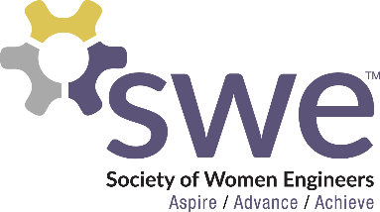  9.15.2022
 | AGENDA  Affinity Lunch  - Speak with prospective high school students about SWE & NDSU while eating a free lunch  - Sept. 24th from 12:15-1:30pm at West Dining Center  Outreach  - Volunteers needed! Sign up in SWEMail  - Girl Scout Event - Oct 1st from 1-4 pm  - Mommy Me and SWE - Sep 24th from 9am-Noon  - Tech Kids - every Tuesday from Oct 4th - Nov 1st  - Tech Teens - Nov 5th from 9am-Noon  Corporate Relations  - Caterpillar Networking Event: Sep 19th from 7-9pm in AG Hill 122  - Resume Building Event: Sep 21st from 7-9pm in AG Hill 300  - If you know someone or a company that would be interested in speaking or participating in and SWE activities, contact Katrina Dietz  Membership  - Mentor/Mentee: Scan this QR code to sign up!  - Sept. Membership Event: Friday, Sept 23rd 6:30-8:30pm in Prairie Rose Room (Memorial Union)  Fundraising  - T-Shirts  - $15 each - Cash or Venmo  - Sold after all monthly meetings  - Fundraising point opportunity! Stuff corporate fundraising letters after tonight’s meeting. 1hr = 1 fundraising point  - Tinsel to continue at next football game  Local Conference  - Feb 17-18, 2022 in Detroit, MI  - 15 Points total to attend, 10 must be fundraising points  - Deadline is end of Fall Semester  Speaker  - Cassie Mott from John Deere |  |  |  | OFFICERS  President:  Samantha Stickler  samantha.stickler@ndsu.edu  VP of Membership:  Ella Murray  elizabeth.murray@ndsu.edu  VP of Outreach:  Lindsay Hagerty  lindsay.hagerty@ndsu.edu  VP of Fundraising  Beth Dittberner  beth.dittberner@ndsu.edu  VP of Corporate Relations  Katrina Dietz  katrina.l.dietz@ndsu.edu  Secretary:  Breanna Wing  breanna.wing@ndsu.edu  Treasurer:  Nikki Stoltenberg  nicole.stoltenberg@ndsu.edu  Webmaster:  Macy Kreuger  macy.krueger@ndsu.edu  Counselor:  Ashley Rolland  aroder88@gmail.com  Advisor:  Dr. Jessica Vold  jessica.l.vold@ndsu.edu  SOCIAL MEDIA  Instagram: @NDSUSWE  Facebook Page:  NDSU Society of Women Engineers  Website: www.ndsuswe.org  Upcoming Monthly Meetings  6:30PM in AG Hill 300  - October 13th  - November 3rd  - December 1st
QR Codes:

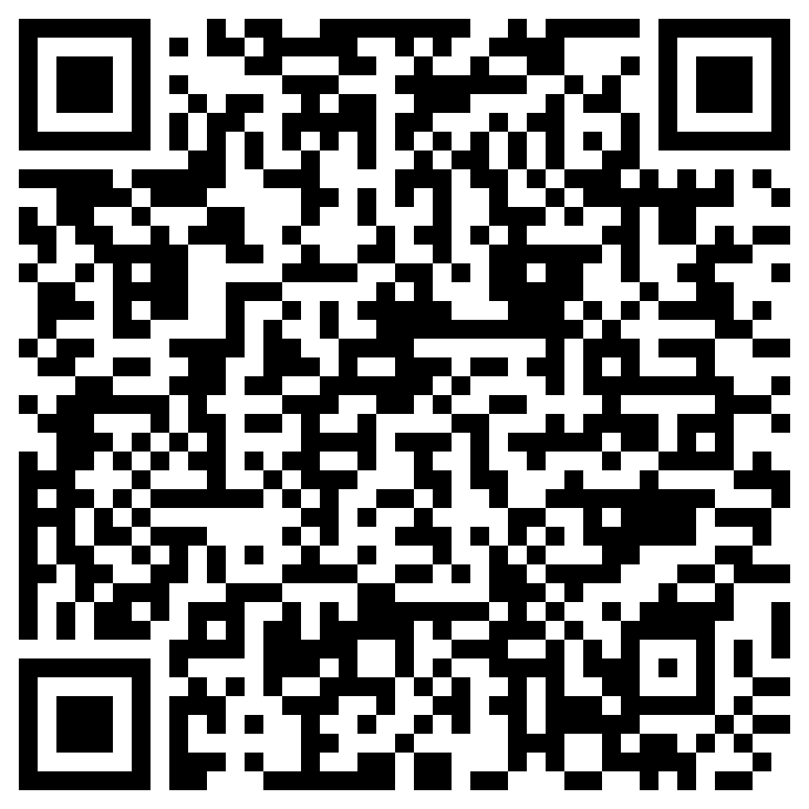
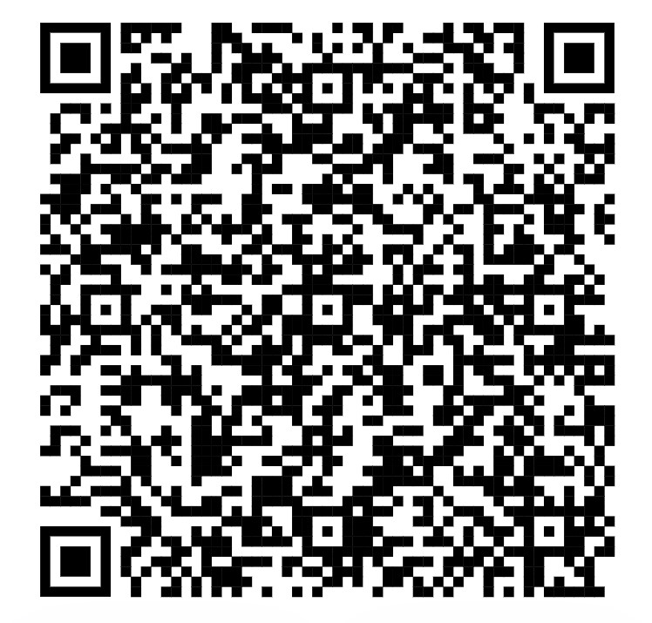
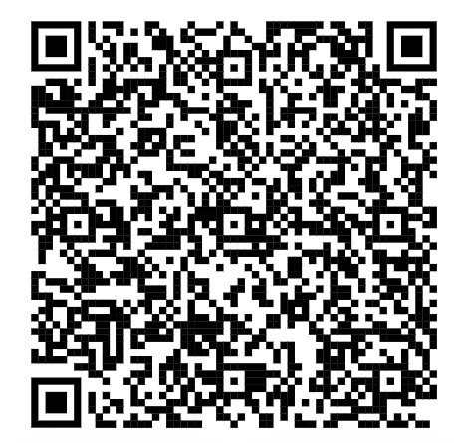
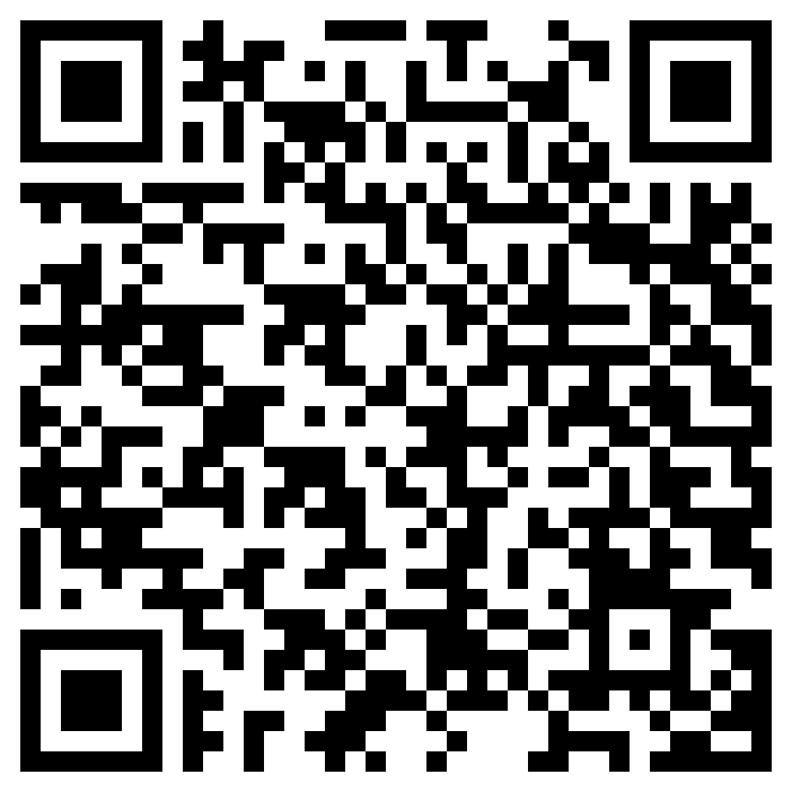
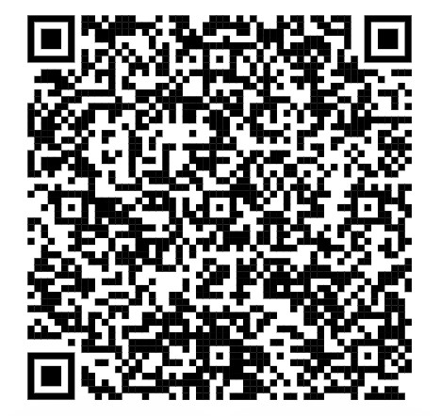
Sign In Snack Survey Affinity Lunch Mentor/Mentee Outreach SIgn Up

