April Monthly Meeting |  |  |  | 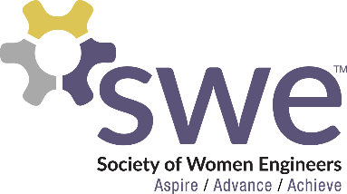  4.13.2023
 | AGENDA  Outreach  - DADDS: Apr. 22nd from 9am - Noon in AG Hill 130/132  Membership  - April Membership Event: Thunder’s Game Room  - 6-8 PM on April 21st in Basement of Union  - Hair Tinsel  - Sign up to work April 14th  - SWE Banquet  - April 29th from 5-7PM in Oceti Sakowin Ballroom  - Must have RSVP’d and paid  WE 23 Nationals  - Oct 26-28, 2023 in Los Angeles, CA  - 30 points total to attend, 15 must be fundraising points by May  Boeing Lunch  - April 18th from Noon-1PM in Engineering Admin. Office Room 106  - Chat while enjoying a free lunch while Boeing signs agreement with NDSU  Officer Team Elections  - All newly elected officers are requested to attend the officer meetings on April 18th and May 2nd at 6:30PM in Student Activities/Zoom |  |  |  | OFFICERS  President:  Samantha Stickler  samantha.stickler@ndsu.edu  VP of Membership:  Ella Murray  elizabeth.murray@ndsu.edu  VP of Outreach:  Lindsay Hagerty  lindsay.hagerty@ndsu.edu  VP of Fundraising  Beth Dittberner  beth.dittberner@ndsu.edu  VP of Corporate Relations  Katrina Dietz  katrina.l.dietz@ndsu.edu  Secretary:  Breanna Wing  breanna.wing@ndsu.edu  Treasurer:  Nikki Stoltenberg  nicole.stoltenberg@ndsu.edu  Webmaster:  Macy Kreuger  macy.krueger@ndsu.edu  Counselor:  Ashley Rolland  aroder88@gmail.com  Advisor:  Dr. Jessica Vold  jessica.l.vold@ndsu.edu  SOCIAL MEDIA  Instagram: @NDSUSWE  Facebook Page:  NDSU Society of Women Engineers  Website: www.ndsuswe.org  Upcoming Monthly Meetings  6:30PM in AG Hill 300  - N/A

QR Codes:
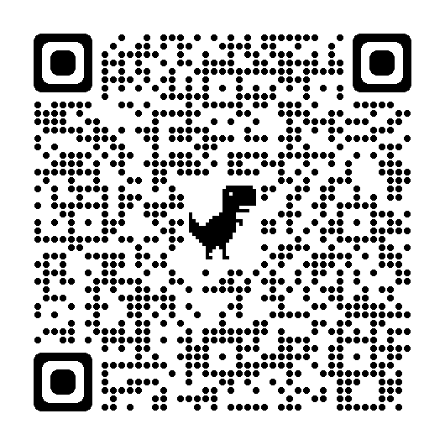
Sign In Outreach Sign Up Hair Tinsel Boeing Lunch Feedback Survey

