March Monthly Meeting |  |  |  | 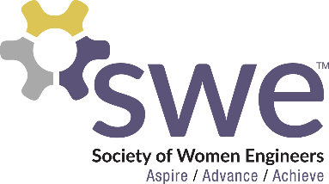  3.23.2023
 | AGENDA  Outreach  - Introduce a Girl to Engineering Day: Mar. 28th, 8am - Noon  - DADDS: Apr. 22nd, 9am - Noon  Corporate Relations  - No more events for this semester  Membership  - Mar. Membership Event: BINGO  - Mar. 30th at Big Top Bingo  - Hair Tinsel  - Sign up to work April 14th  Webmaster  - Submit any fundraising ideas!  Fundraising  - T-Shirts & Magnets & Sweatshirts  - $15 per shirt & $3-4 per magnet/sticker - Cash or Venmo  - 1 Fundraising Point for buying 1 shirt ot 2 stickers/magnets  SWE Scholarship 2023  - Application in SWEmail  - Requirements: minimum 25 points and graduating Dec. 2023 or later  - Due April 8th at Noon  WE 23 Nationals  - Oct 26-28, 2023 in Los Angeles, CA  - 30 points total to attend, 15 must be fundraising points by May  Officer Team Nominations  - Nominations open through email until the end of the day on April 6th  - Email: samantha.stickler@ndsu.edu  - Elections at April Monthly Meeting  - Requirement of 4 points to vote  Speaker  - Michelle Nistler from Medtronic |  |  |  | OFFICERS  President:  Samantha Stickler  samantha.stickler@ndsu.edu  VP of Membership:  Ella Murray  elizabeth.murray@ndsu.edu  VP of Outreach:  Lindsay Hagerty  lindsay.hagerty@ndsu.edu  VP of Fundraising  Beth Dittberner  beth.dittberner@ndsu.edu  VP of Corporate Relations  Katrina Dietz  katrina.l.dietz@ndsu.edu  Secretary:  Breanna Wing  breanna.wing@ndsu.edu  Treasurer:  Nikki Stoltenberg  nicole.stoltenberg@ndsu.edu  Webmaster:  Macy Kreuger  macy.krueger@ndsu.edu  Counselor:  Ashley Rolland  aroder88@gmail.com  Advisor:  Dr. Jessica Vold  jessica.l.vold@ndsu.edu  SOCIAL MEDIA  Instagram: @NDSUSWE  Facebook Page:  NDSU Society of Women Engineers  Website: www.ndsuswe.org  Upcoming Monthly Meetings  6:30PM in AG Hill 300  - April 13th
QR Codes:
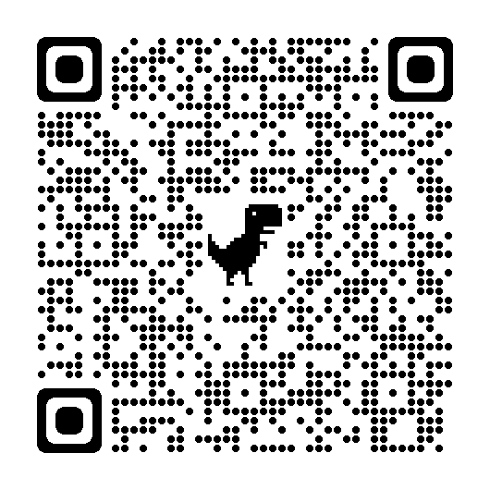
Sign In Outreach Sign Up Fundraising Ideas Hair Tinsel

