February Monthly Meeting |  |  |  | 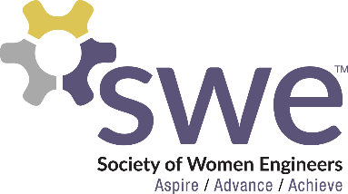  2.9.2023
 | AGENDA  Outreach  - Introduce a Girl to Engineering Day: Feb. 23rd, 8am - 1pm  - DADDS: Apr. 22nd, 9am - noon  Corporate Relations  - No more events for this semester  Membership  - Feb. Membership Event: Painting and Mocktails!  - Feb. 24th from 6-8 PM in Nueta  - Hair Tinsel (1 Fundraising Point)  - Sign up to work Feb. 10th  Webmaster  - Submit any fundraising ideas!  Fundraising  - SHAC Dates available in the sign up below  - T-Shirts & Magnets & Sweatshirts  - $15 per shirt & $3-4 per magnet/sticker - Cash or Venmo  - 1 Fundraising Point for buying 1 shirt ot 2 stickers/magnets  Join the Officer Team  - Nominations at March Monthly Meeting  - Minimum 2.5 GPA  - Voting on April Monthly Meeting  - Minimum 4 points to vote  - Sit in at an officer meeting: 2/21 or 3/7 at 6:30 PM in the student activities office  WE 23 Nationals  - Oct 26-28, 2023 in Los Angeles, CA  - 30 points total to attend, 15 must be fundraising points by May  Senior Spotlight  - Nikki Stoltenberg  Speaker  - Laura Jordahl from Ulteig |  |  |  | OFFICERS  President:  Samantha Stickler  samantha.stickler@ndsu.edu  VP of Membership:  Ella Murray  elizabeth.murray@ndsu.edu  VP of Outreach:  Lindsay Hagerty  lindsay.hagerty@ndsu.edu  VP of Fundraising  Beth Dittberner  beth.dittberner@ndsu.edu  VP of Corporate Relations  Katrina Dietz  katrina.l.dietz@ndsu.edu  Secretary:  Breanna Wing  breanna.wing@ndsu.edu  Treasurer:  Nikki Stoltenberg  nicole.stoltenberg@ndsu.edu  Webmaster:  Macy Kreuger  macy.krueger@ndsu.edu  Counselor:  Ashley Rolland  aroder88@gmail.com  Advisor:  Dr. Jessica Vold  jessica.l.vold@ndsu.edu  SOCIAL MEDIA  Instagram: @NDSUSWE  Facebook Page:  NDSU Society of Women Engineers  Website: www.ndsuswe.org  Upcoming Monthly Meetings  6:30PM in AG Hill 300  - March 23rd  - April 13th
QR Codes:
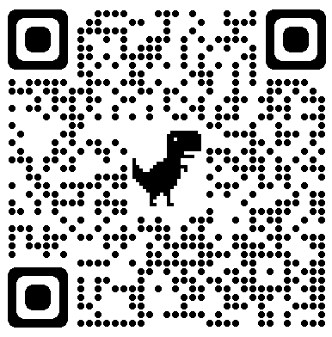
Sign In Outreach Sign Up Fundraising Ideas SHAC Dates Hair Tinsel

