November Monthly Meeting |  |  |  | 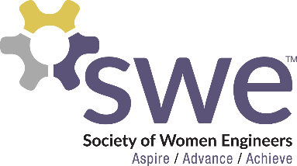  11.3.2022
 | AGENDA  Outreach  - Volunteers needed! Sign up in SWEMail  - Tech Teens - Nov 5th from 9am-Noon in AG Hill 130/132  Corporate Relations  - Corporate Panel  - November 8th from 7-9 PM AG Hill 122  - If you know someone or a company that would be interested in speaking or participating in and SWE activities, contact Katrina Dietz  Membership  - Nov. Membership Event: Movie & Snack Night!  - November 18th from 6:30-8:30pm in Nueta Room (Union)  - Homework/Open Study Session Nights with Medley (no points)  - 11/18, 11/22, & 12/6 at 5-7PM in AG Hill 234  - Hair Tinsel (1 Fundraising Point)  - Sign up to work the Fridays before game days in the Union!  Webmaster  - Instagram Takeovers  - Day in the life of SWE members & open to everyone!  Fundraising  - T-Shirts & Magnets  - $15 per shirt & $3 per magnet - Cash or Venmo  - 1 Fundraising Point for buying: (max 1 point)  - 1 T-Shirt or 2 stickers or magnets  - Sold after all monthly meetings  SWE Point System  - Used for: conferences, scholarships, voting  - Vote: 4 points  - Scholarships: 25 points by application deadline (April)  - Nationals: 30 total to attend, 15 must be fundraising by May  - You pay for registration, ubers/buses to hotels, and food  Local Conference  - Feb 17-18, 2022 in Detroit, MI  - 15 points total to attend, 10 must be fundraising points by December  Speaker  - Brie Bednarek from Abbott! |  |  |  | OFFICERS  President:  Samantha Stickler  samantha.stickler@ndsu.edu  VP of Membership:  Ella Murray  elizabeth.murray@ndsu.edu  VP of Outreach:  Lindsay Hagerty  lindsay.hagerty@ndsu.edu  VP of Fundraising  Beth Dittberner  beth.dittberner@ndsu.edu  VP of Corporate Relations  Katrina Dietz  katrina.l.dietz@ndsu.edu  Secretary:  Breanna Wing  breanna.wing@ndsu.edu  Treasurer:  Nikki Stoltenberg  nicole.stoltenberg@ndsu.edu  Webmaster:  Macy Kreuger  macy.krueger@ndsu.edu  Counselor:  Ashley Rolland  aroder88@gmail.com  Advisor:  Dr. Jessica Vold  jessica.l.vold@ndsu.edu  SOCIAL MEDIA  Instagram: @NDSUSWE  Facebook Page:  NDSU Society of Women Engineers  Website: www.ndsuswe.org  Upcoming Monthly Meetings  6:30PM in AG Hill 300  - December 1st
QR Codes:
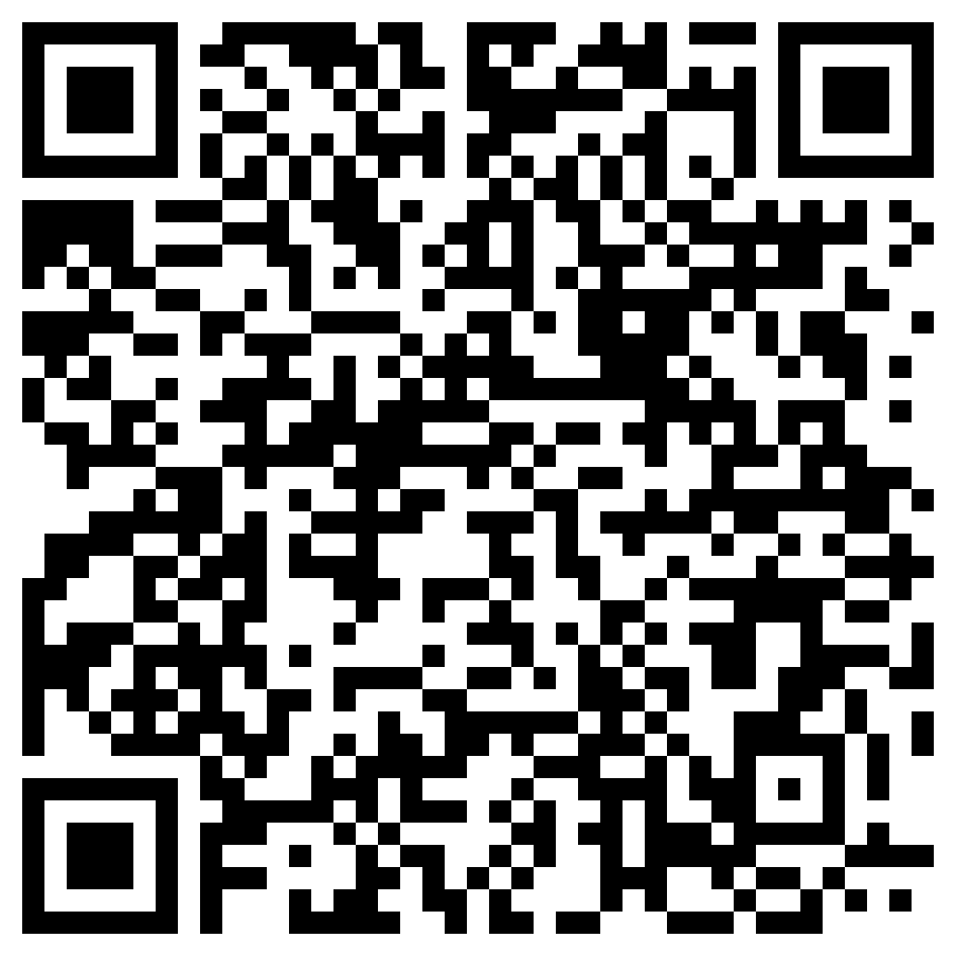
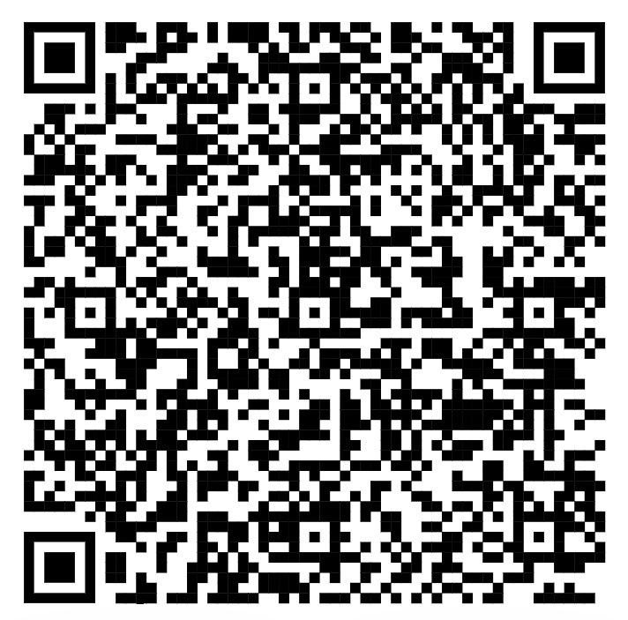
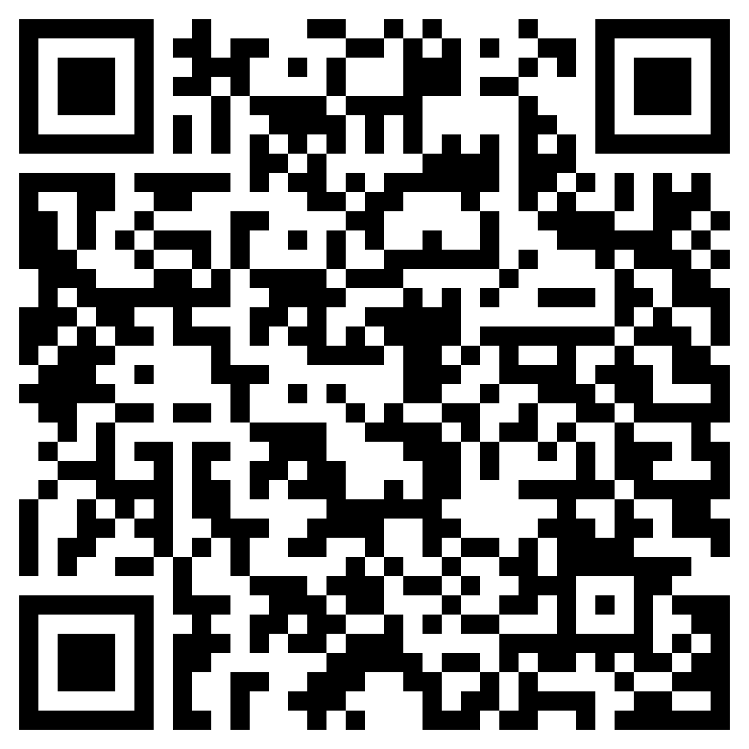
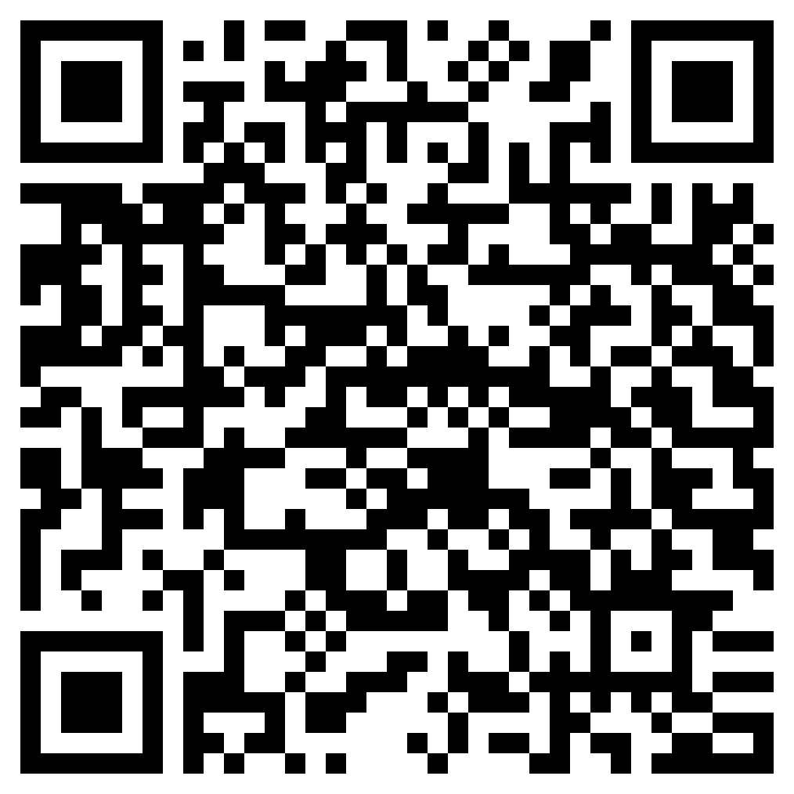
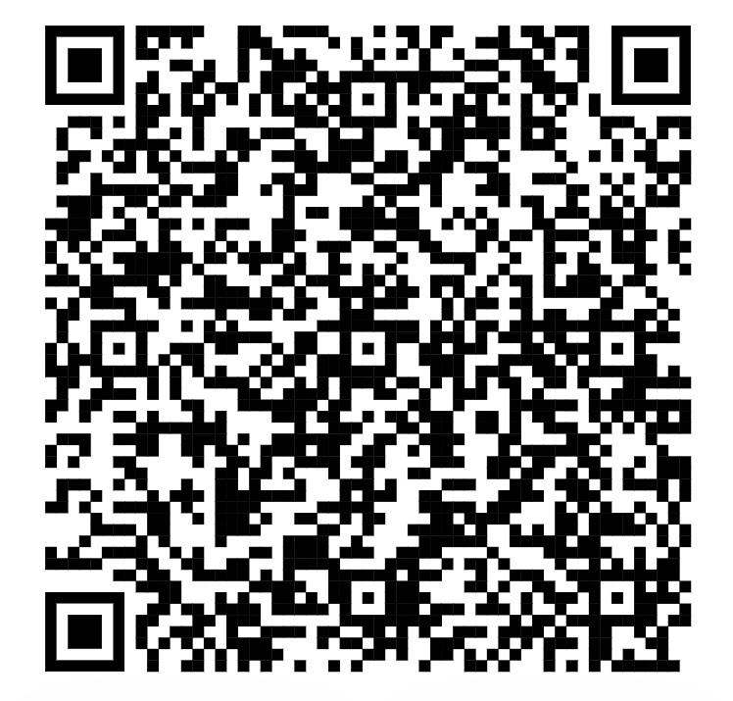
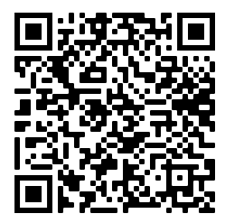
Sign In Outreach SIgn Up Panel ?’s Movie Night Hair Tinsel Instagram Takeover

