Welcome Meeting |  |  |  | 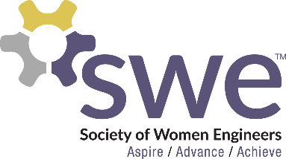  9.03.2020
 | AGENDA  Outreach  - Most Fall Outreach Events are Cancelled  - Looking for alternative outreach opportunities  Membership  - Picnic @ Churchill Field, Friday, September 18th 7-9 pm  - Snacks and Lawn Games Provided  - Bring your own Blanket or Chair  Corporate Relations  - Virtual Resume Building Event: Monday, September 21st 5:30-7:30 p.m. (Monday before the Career and Tech Expo)  - First Monthly Meeting Speakers: Our Section Counselor, Ashley! And a Representative from the NDSU Career Center  Fundraising  - Stuffing Letters - after September 10th Meeting  - Chipotle Fundraiser – October 10th 5 - 9 pm  - Purchase SWE T-Shirt ($10) & SWE Bracelet ($5)  Nationals Conference  - Completely Virtual 2-Week Format  - Registration Open to Everyone  Senior Spotlights  - Lindsey Prestholdt  - Contact Kjersten if interested in presenting at a meeting  Speakers  - Jerry South, from NDSU Career Center  - Ashley Rolland, NDSU SWE Section Counselor |  |  |  | OFFICERS  President:  Kjersten Winkelman  kjersten.winkelman@ndsu.edu  VP of Membership:  Sabrina Kase  sabrina.kase@ndsu.edu  VP of Outreach:  Breeya Pederson  breeya.pederson@ndsu.edu  VP of Fundraising  Kyleigh Correll  kyleigh.correll@ndsu.edu  VP of Corporate Relations  Joncy Mastel  joncy.mastel@ndscs.edu  Secretary:  Samantha Stickler  samantha.stickler@ndsu.edu  Treasurer:  Abi Henderson  abigail.a.henderson@ndsu.edu  Counselor:  Ashley Rolland  aroder88@gmail.com  Advisor:  Dr. Jessica Vold  jessica.l.vold@ndsu.edu  SOCIAL MEDIA  Twitter: @NDSUSWE  Facebook Page:  NDSU Society of Women Engineers  Instagram: @NDSUSWE  SnapChat: ndsuswe  Website: www.ndsuswe.org  Upcoming Monthly Meetings  - October 8th  - November 12th

